**Frontex opens Risk Analysis Cell in Senegal**

2019-06-13

On 12 June, Frontex, the European Border and Coast Guard Agency, opened a Risk Analysis Cell in Dakar in cooperation with Senegalese authorities within the framework of the Africa-Frontex Intelligence Community (AFIC).

Taking part in the opening in Senegal were representatives of Gambia, Ghana, Guinea, Mali, Niger and Nigeria, as well as other international partners.

The role of the cells, which are run by local analysts trained by Frontex, is to collect and analyse strategic data on cross-border crime in various African countries and support relevant authorities involved in border management.

This includes information on illegal border crossings, document fraud, trafficking in human beings and other types of cross-border crime. It is shared with authorities at national and regional level to produce analysis and policy recommendations, as well as with Frontex. The project is financed by the European Commission (DG DEVCO).

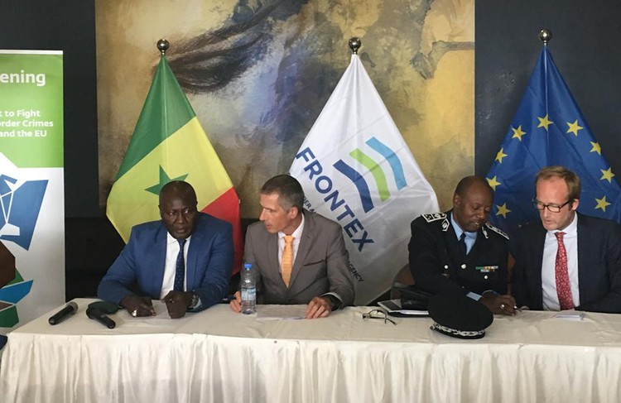

Cooperation between Frontex and 26 members of AFIC is a key element in battling cross-border crime and security threats affecting African countries and the EU. AFIC was launched in 2010 to provide a framework for regular information sharing about migrant smuggling and border security threats. It foresees close cooperation with a number of countries along the main smuggling routes. This is done through a series of training activities to develop national and regional strategies to fight cross-border crime. It also includes setting up integrated border management systems, as well as improving the collection, sharing and analysis of relevant data.